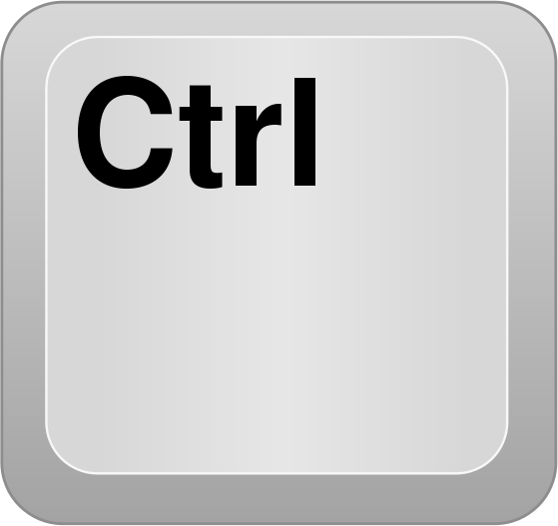
COPY

& “C”

PASTE

& “V”

CUT

& “X”

Select All

& “A”

Add Bookmark
& “D”

New Tab

& “T”

PRINT

& “P”

Find
(This can be used to search a document or website for a specific word or phrase)

& “F”
UNDO

& “Z”

Zoom In

& “+”

Zoom Out
& “-”

Reset Zoom
& “0”

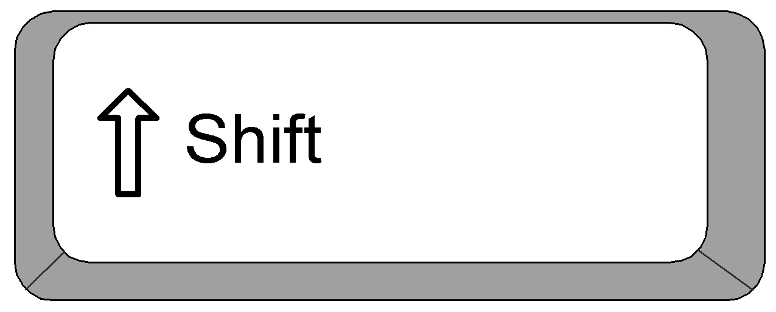
Take a Screenshot
&
&

