Brain POP Walk Through
Teachers:
When going to BrainPOP, use the Google Apps feature in your Gmail.
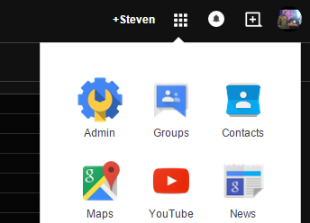
Make sure to click the “More” part of the Waffle and select the BrainPOP App. 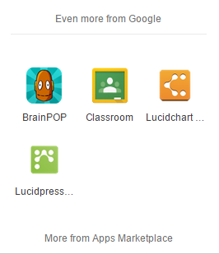
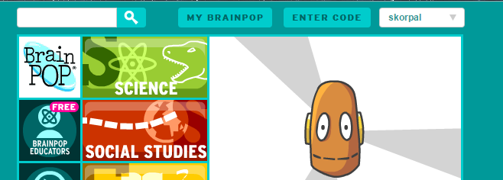
When you click on the App, you will be directed to the BrainPOP’s website as well as being logged in automatically

You will notice your name in the top right corner of the BrainPOP website.
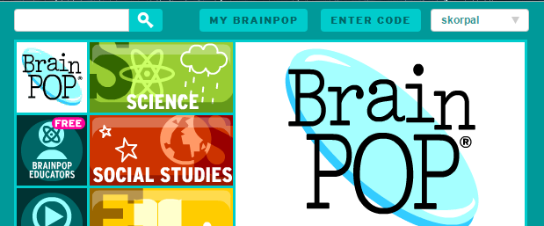
To create a class for your students, click on “My Brainpop” and click “My Classes”
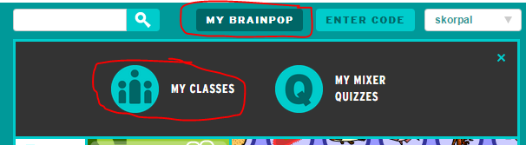
Create your class name, try to be specific to the class/year as you will be competing for class names with everyone else who has ever used Brainpop in the world. I have seen a template of classroom name creation using the name of the teacher, class, year. (ex. Korpal-Social-2015)
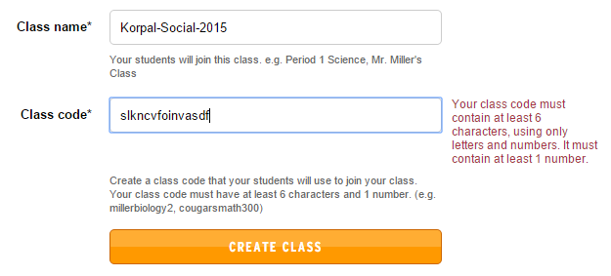
Create a class code that you will provide to your students. This code will also be competing against everyone else who has ever used Brainpop, so make sure to write down the hieroglyphics before hitting the “Create Class” button

When you created the class for your students, you will see the following.
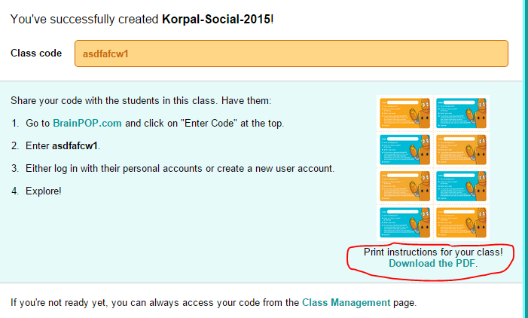

You can print the instructions for your students by clicking the “Download the PDF” hyperlink.

Instruct your class to go to their D124.org email account, click the waffle, expand to “even more”, and click Brainpop.

Your students will be prompted with “use current account, or create new account”. Make sure the students make a NEW account, which the students will never have to do again in the future. I would recommend that the students use their login username as their new account.
Instruct your students to click on “enter code” and put in the class code you created above.
The students will now be logged into your class, and the previous method you used to get around Brainpop will be the same as of this point.

If you have any questions, please contact the IT department.

Thank you,

